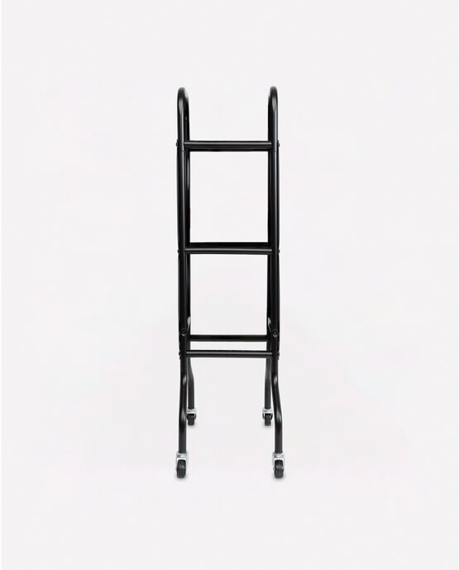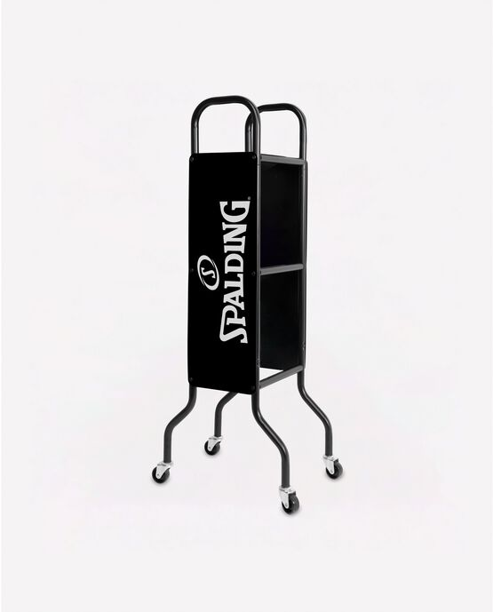

SPALDING BASKETBALL CART

This ball cart holds up to 3, 6 or 12 balls as once and can easily wheel from the garage to the driveway.

**DETAILS:**

* Holds 3, 6, or 12 full-size basketballs
* Powder-coated Steel
* Full Swivel casters for easy movement
* Designed for indoor or outdoor play
* Backed by Spalding’s Warranty